39.5: a) In the Bohr model 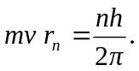 The de Broglie wavelength is This equals the orbit circumference.
b) 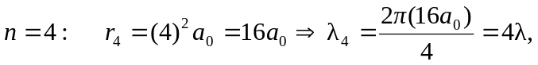
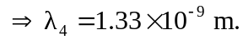
The de Broglie wavelength is a quarter of the circumference of the orbit, 